https://developer.uber.com/products

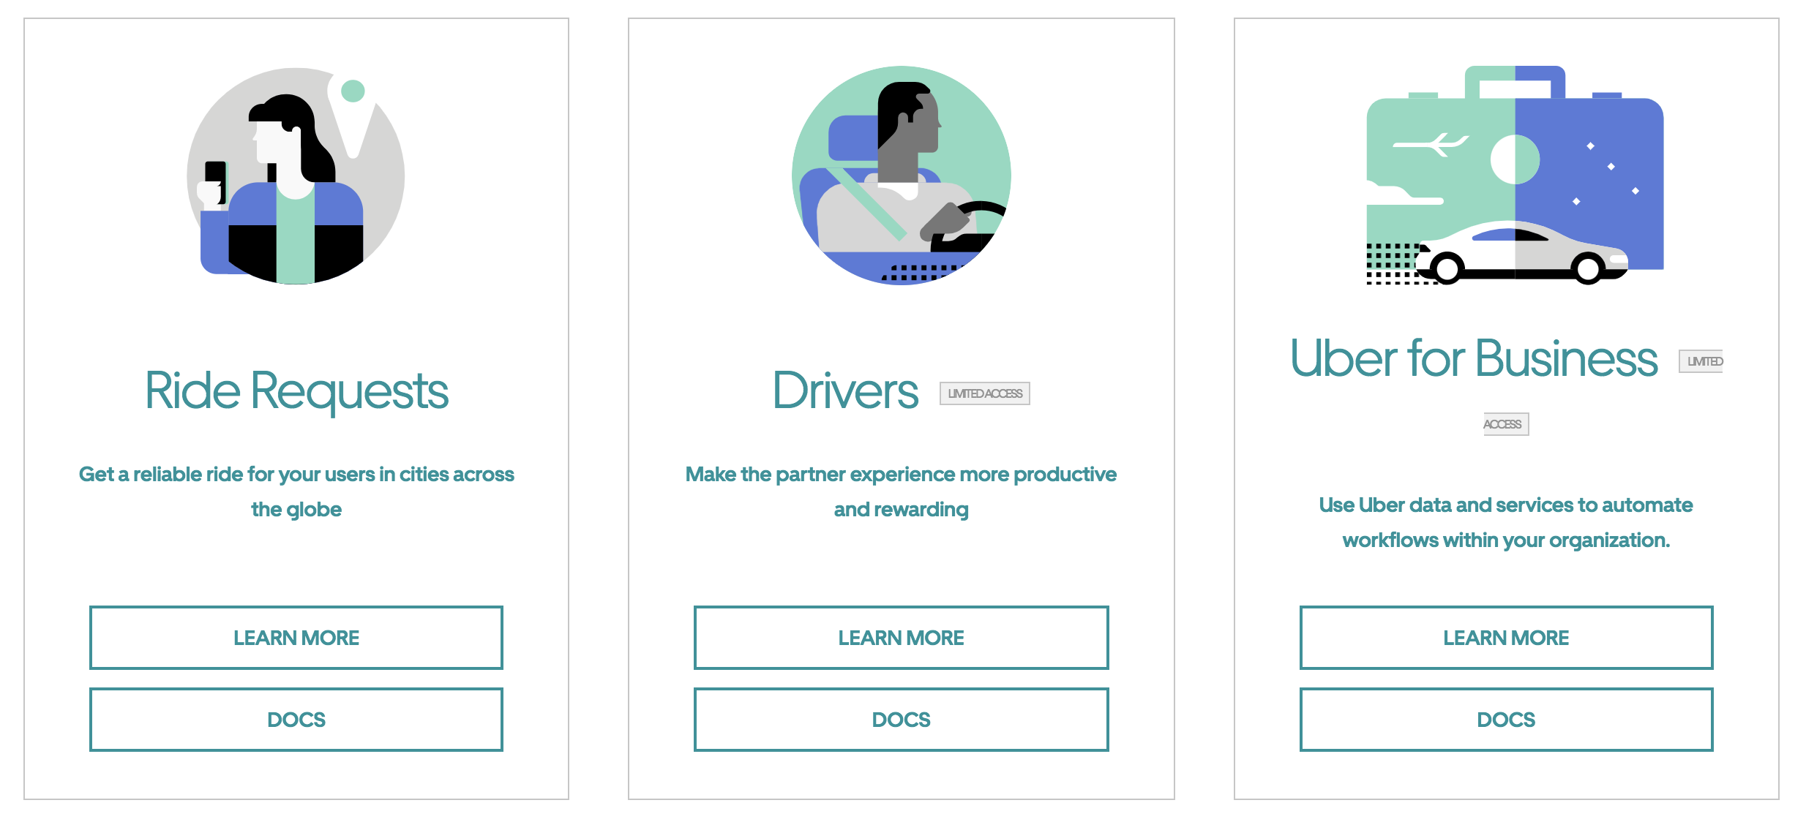

<https://developer.uber.com/docs/riders/ride-requests/tutorials/api/introduction>

https://about.twitter.com/company